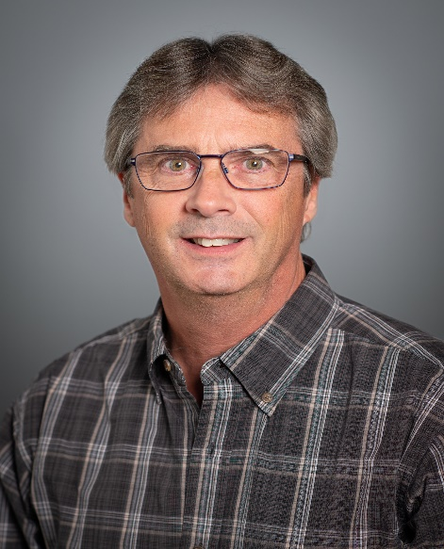**Curriculum Vitae**

**Tadd P. Schroeder**

**BSN, RN, TNS, CCRN**

**Legal Nurse Consultant**

**505 Pleasant Court**

**Chatham, IL 62629**

**Cell: 217-414-5023**

**Email: tadds@comcast.net**

**Professional Profile**

I have over 25 years of pre-hospital experience as a volunteer firefighter/EMT turned RN. I worked 16 years in the aviation industry prior to entering the nursing profession. I have a total of 18 years of critical care experience in the following roles: Bedside RN in the emergency department and Trauma/Surgical ICU, Organ Recovery Coordinator (organ transplant), Rapid Response RN, Code Team Leader, Trauma/Burn ICU Nurse Manager, and Patient Safety Coordinator. I have spent my career in healthcare assessing and caring for critically ill patients. I have extensive history in abdominal pressure monitoring, blood administration, CRRT, cardiac monitoring, documentation, fluid resuscitation, infection prevention techniques, neuro critical, including stroke and traumatic brain injuries¸ precepting new nurses, vasoactive medication administration, and ventilator support. In my roles as ICU charge nurse and Rapid Response RN, I responded to declining patients throughout the hospital, implementing standing orders and protocols, assisting floor nurses until a physician arrived bedside. I also provided subject matter resources to less experienced staff, ensuring safe and appropriate patient care.

I have participated in many committees, including being the only non-physician member of the Clinical Competency Committee for general surgery residents at a medical school. I currently work as a Patient Safety Coordinator at a 500 bed Level 1 Trauma Center. In this role, I review all patient safety events, interview colleagues and medical staff, provide written documentation of my findings, and perform root cause analysis of reportable events. My experience allows me real world understanding and practical knowledge of what is required to be a competent healthcare provider in today's society.

**Education**

**Bachelors of Science in Nursing, May 2017** Benedictine University, Springfield, IL

**Associate in Applied Science – Nursing May 2006** Lincoln Land Community College

**Nursing Experience**

**Springfield Memorial Hospital, Springfield, IL September 2023 - Present**

**Patient Safety Coordinator**

* Review hospital electronic event reporting system for accuracy and follow up.

• Internal investigations, including chart review, physician, and staff interviews.

* Serious Safety Events and Root Cause Analysis – Investigation, preparation, and senior

leadership presentation.

* Assist with external regulatory investigations and site surveys.

• Support colleagues through Second Victims Program and Just Culture initiatives.

**Springfield Memorial Hospital, Springfield, IL February 2020- August 2023**

**Nurse Manager – Trauma/Burn ICU**

• Direct Supervision of 60+ colleagues

• Responsible for recruiting, hiring, retention, and scheduling of all staff

• Fiscally responsible for all unit expenses, including timecard editing and approval

• Customer relations with patients and visitors

• Physician relationship building and collaboration

**Springfield Memorial Hospital, Springfield, IL October 2017 – February 2020**

**Rapid Response Registered Nurse**

• Respond to house wide rapid response calls, stroke and sepsis alerts

• Implementation of standing orders for patient stabilization prior to physician response

• Proactively round on nursing units, evaluating patients with risk for decline

• Collaborate with physician colleagues regarding patient plan of care / transfer

• Assist staff nurses with assessment and intervention of complex / unstable patients

**Springfield Memorial Hospital, Springfield, IL September 2015 – February 2020**

**Critical Care Transport Program Coordinator**

• Quality review of all patient care reports

• Provide feedback to transport agencies and providers

• Education and testing of CCEMTP and CCRN providers

• Annual protocol and written test revisions

**Springfield Memorial Hospital Springfield, IL June 2015 –October 2017**

**Registered Nurse III - Surgical / Trauma ICU**

• Charge nurse / staff nurse

• Care and collaboration of complex trauma, surgical, and neuro patients

• Staff assignments and delegation

• Trauma Nurse Specialist

• Rapid response and Code Team

• Unit representation within hospital committees and councils

**Gift of Hope Organ & Tissue Donor Network June 2014 – June 2015**

**Organ recovery Coordinator**

• Medical management of donors in the ICU

• Facilitate communication between placement staff and transplant centers

• Establish availability of hospital operating suites

• Coordinate air and ground transportation for transplant teams

• Packaging and disposition of recovered organs

**Springfield Memorial Hospital, Springfield, IL March 2008 – April 2015**

**Registered Nurse II - Surgical / Trauma ICU**

• Charge nurse / staff nurse

• Care and collaboration of complex trauma, surgical, and neuro patients

• Staff assignments and delegation

• Trauma Nurse Specialist

• Rapid response and Code Team

• Unit Based Council Chair ∙ Preceptor for new staff RNs

**Springfield Memorial Hospital, Springfield, IL June 2006 – March 2008**

**Registered Nurse – Emergency Department**

• Patient triage and assessment in collaboration with ED medical providers

• Effectively managed rapidly developing and emergent situations

• Trauma Nurse Specialist in Level 1 Trauma Center

**Springfield Memorial Hospital, Springfield, IL September 2003 - June 2006**

**Emergency Medical Specialist**

• Provided quality patient-centered care

• Phlebotomy, specimen collection

• Obtained vital signs, splinting, discharge education

**Certifications**

ACLS, BLS, CCRN, PALS, TNS (Trauma Nurse Specialist)

**Professional Organizations**

American Nurses Association, American Association of Critical**-**Care Nurses

**COMMUNITY INVOLVMENT / VOLUNTEER SERVICES**

**Chatham Fire Department, Chatham, IL June 2007 - Present**

Certified Firefighter II, EMT-I

**Pawnee Fire Department, Pawnee, IL**

Certified Firefighter II, EMT-I **Mar 1999- Apr 2007**