**Curriculum Vitae**Michael R Henderson:  
XL Aviation Aircraft Operations

Legal Eagles Aviation Experts

Aviation Expert, R&D, Process Manufacturing ExpertApplied Physicist, Harvard Business School, MBA  
University of Minnesota, MS, Physics

818 Luz Ct  
Danville CA 94526

Tel: 925 961 6135

E-mail: [**Michael.roy.henderson@gmail.com**](mailto:Michael.roy.henderson@gmail.com)

[**https://www.linkedin.com/in/mrhender/**](https://www.linkedin.com/in/mrhender/) [**www.xlaviationtailwheel.com**](http://www.xlaviationtailwheel.com)**/**

**https://legaleaglesaviation.com/**

**Summary of Expertise**   
**Career Design/Manufacturing Physicist,Flight Operation and Aviation Legal Expert Business Owner:** Over 25 years of critical problem solving providing General Aviation Technology and Pilot Training. Expert in determining the critical factors that determine all manner of aviation outcomes connecting pilot capability, training, emotional fitness, state of being and the relevant relationships between pilot, machine and environment from manufacturing to flight. XL Aviation exclusively provides direct training and consulting resources to corporate fleets, manufacturers and various research organizations private and public including Joby VTOL aircraft system development and other leading edge Aviation manufacturers (Textron, Garmin, Bell and others).   
 **Physicist:** Hands-on, real-world Applied Physicist, inventor and builder of key technologies, sought technical resource focused on FAA requirements, historical trends, aircraft capabilities as well as actual pilot training and behavior characteristics relevant to critical performance cause and effect. Skilled and experienced in critical state of the art problem solving techniques developed and used by NASA, IBM, Boeing, Textron, Seagate, Apple, UCT and others.

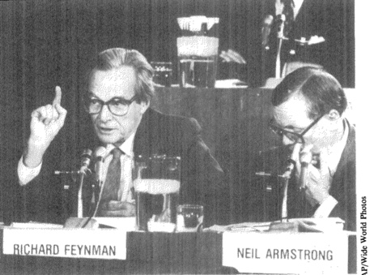

**Employment**

**Legal Eagles Aviation Witnesses: Owner: 2023-Present: Owner**  
 • “We determine cause and effect between multiple pilot, machine and environment KPIV’s leading to

outcome KPOV’s critical to event. Capability, training, state of being, and the relevant relationships

between pilot, machine, and environment.”   
• “By applying up-to-date state of the art critical problem-solving techniques with 25 + years of hands-on

Aviation experience conclusive results are accurate, without bias and often not obvious….”

• Pilot, equipment, environment combined analysis techniques used to determine Cause and Effect.

• FAA/AMA-GAMA Requirements Expert.

**XL Aviation**Livermore, CA**,*****Owner, CEO,*** 2012-Present•.Very profitable and growing aircraft training, maintenance, manufacturing, lease and rental business.  
• Deeply involved with FAA requirements as applied to aircraft equipment, qualification processes and

operation in flight.

• Hi Tech methods applied to Flight School Training and Aircraft Maintenance and assembly.

• 1,250 GA Pilots Trained.   
  
• Maintenance and Operation of over 25 Unique Military, Experimental & Certified Aircraft• Partner with avionics companies in the research, development, and testing of autonomousflight, flight

training methods and associated technologies.

**Grote Industries** Madison, IN***, Vice President, Engineering*,** 2014-2016Private Corporation and leading worldwide manufacturer of LED lights and lighting technology for Aviation and Heavy Transportation. Numerous Patents.   
• Oversaw R&D to manufacturing of FAA-approved wireless LED systems for Bell Aircraft.

**Modumetal, LLC** Seattle, WA, ***Vice President, Operations and Engineering*,** 2013-2014  
• Research, development and production of nano-laminated metal alloys for Oil & Gas, Aviation and Civil/Government agencies.   
  
**Avaya** Santa Clara, CA***, Vice President, Product Engineering****,* 2010-2013  
• Reported to CEO, led product development, production, Quality Control and OEM acceptance of telecommunication hardware for the US Military and Private Enterprise.

**Seagate Technology** US, Singapore, China, ***Vice President, Engineering****,* 2000-2010  
• Developed state of the art Manufacturing and Deming /6-SIGMA/ISO/ based quality control processes later adopted by Boeing, Textron, GAMA (General Aviation Manufacturing Association), EAA (Experimental Aircraft Industry) and all major outsourcing manufacturers.   
• Creator of the Technology used to predict failure before it occurs and manage process manufacturing accordingly.

• 0 DPPM: First to demonstrate, implement and maintain 0 defect/1M MTBF (0 DPPM).

**Education  
• Harvard Business School,** Executive Master of Business Administration  
• **University of Minnesota,** MS Physics

**Professional Associations**• IAC 2023 Sponsor and Participant: IAC World Aerobatic Championship,  
• APS, American Physics Society  
• FAA, AOPA, IAC, EAA, Member/Contributor/  
• Six Sigma Champion (Applied Statistical Control)